Job Title Enforcement Manager
Job Purpose Working with and supporting the Deputy Director, National Enforcement to deliver all enforcement related functions, ensuring enforcement processes are followed, and supporting CQC’s approach across its full range of regulatory powers.

You will be responsible for leading and managing the development of the future long-term approach and business focus for all enforcement related activity in your area of responsibility; and improving the quality and consistency of enforcement action taken. You will be a subject matter expert in the development of the end to end process, policy, guidance, templates and identifying co-dependencies.
This role is accountable to the Deputy Director, National Enforcement.
Accountabilities • Lead and manage a national enforcement team to deliver efficient, consistent and robust investigations or review of representations.
- Deputises for the Deputy Director, National Enforcement, as appropriate
- Oversee consistency of enforcement action taken in your area of responsibility and transparency of decision making (civil and criminal)
- Lead on key areas of responsibility as required, e.g. GAIN (Government Agency Intelligence Network), RIPA (Regulation of Investigatory Powers Act)
- Ensure the process for managing enforcement oversight is appropriately managed in line with relevant policies and procedures
- Develop and support the operational implementation of Enforcement policy and strategy
- Develop any future model for enforcement, supporting identification and implementation of enforcement improvement initiatives
- Ensure consistent evidence-based judgments at all levels across the areas of responsibility
- Ensure colleagues have the appropriate support to undertake their role and career development including supporting forums for enforcement learning and developing knowledge and skills development
- Provides line management to team colleagues in the area of responsibility ensuring colleagues have the appropriate support to undertake their role and aid career development
- Ensures delivery of relevant Key Performance Indicators
- Support engagement and provision of advice to internal and external stakeholders and promotion of the enforcement strategy and the delivery of consistency
- Drive improvements on data reporting systems and enforcement management information, through collaboration with CQC teams
- Oversee management of enforcement equipment, to identify trends and changes in corporate enforcement needs, to recommend and develop business cases for improvements
- Promote a strong data culture across CQC in line with the organisational data strategy
- Maintains personal expertise in enforcement by participating in continuing professional development and the implementation of personal development plans for self and others
- Plays an active corporate leadership role across their area of Operations, including role modelling inclusive behaviours in everyday interactions and promoting diversity and equality of opportunity, treating everyone with dignity and respect and challenging discrimination.
- Promotes a culture of respect and fairness and understands personal responsibilities around delivering against CQC diversity and inclusion strategy.
- Role models and supports others to instil CQC values into everything that we do.
Specific Essential:
knowledge, • Knowledge of the Health & Social Care Act and associated skills and regulation
experience • Proven track record in the regulation of health and social care (civil and criminal) and credibility in the Enforcement function
- Excellent knowledge and experience of appropriate systems,
tools and methods to underpin timely and proportionate regulatory decision making i.e. the right action at the right time
- Experience of line managing people and performance
- Knowledge and experience of offering constructive challenge and working as part of a wider team
- Ability to coach and develop colleagues
- Knowledge and experience of risk management within a health and care setting
- Excellent communication skills including, demonstrating an ability to engage with colleagues at all levels
- Experienced in building strong relationships internally and externally and delivering with and through others
- Well-organised and methodical with high attention to detail, strong analytical skills, triage and risk assess information, with a view to appropriate escalation
- Excellent communication skills, both written and oral, including the ability to relate to and communicate with people at all levels and in multiple settings

Desirable:
- CPIA trained (Disclosure)
- Experience of working in health or social care such as regulation, service provision, private or voluntary sector
- Experienced suspect interviewer and/or statement taker
- Achieve Best Evidence (ABE) Interview trained

Values & Behaviours
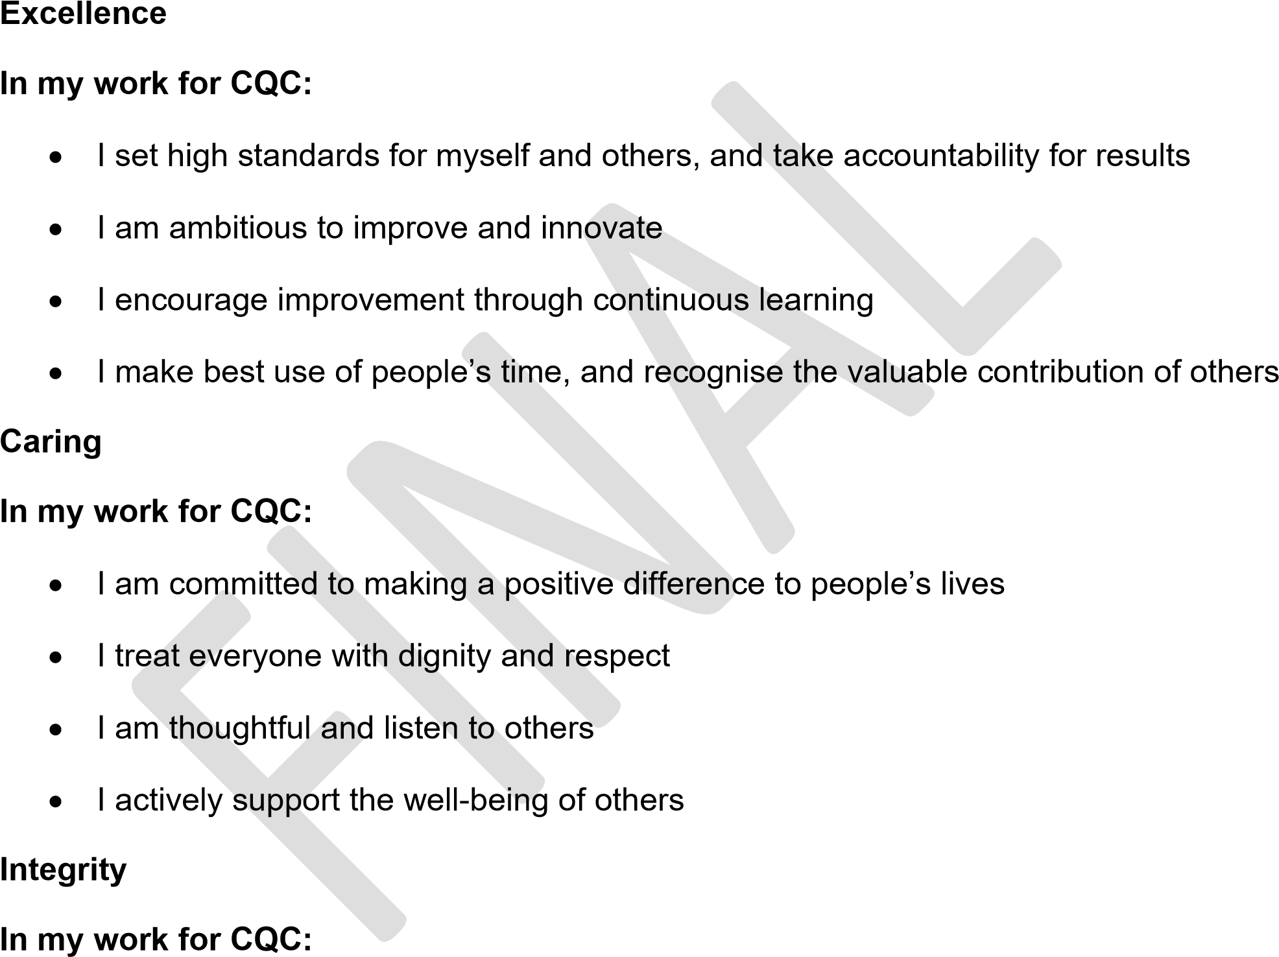
- I ensure my actions reflect my words
- I am fair and open to challenge and have the courage to challenge others
- I positively contribute to building trust with the public, colleagues and partners
Teamwork
In my work for CQC:
- I provide high support and high challenge for my colleagues
• | I understand the impact my work has on others and how their work affects me
• | I recognise that we can’t do this alone
• | I am adaptable to the changing needs of others

